W205 summer 2017 section 2 – Lab06 - K Iwasaki

***Topology file***

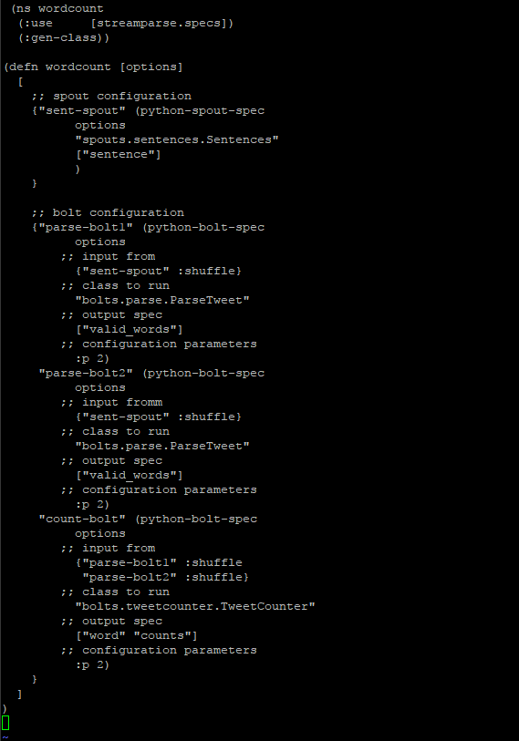

***Screenshot of running application***

